|  |
| --- |
| *VENI App* |
| **User Documentation** |
| **SE 6387 Advanced Software Engineering Project**  **R.Z. Wenkstern**    ***April 22, 2015*** |

|  |
| --- |
| **Group *X*** |
| **Brian MacKay** |
| **Anant Kambli** |
| **Raleigh Murráy** |
| **Shahed Shuman** |
| **Kathryn Whitmire** |

# Revision History

|  |  |  |  |
| --- | --- | --- | --- |
| **Version** | **Date** | **Description** | **Authors** |
| 1.0 | 27-Mar-2015 | Initial draft | K. Whitmire |
| 2.0 | 22-Apr-2015 | Updates to steps | K. Whitmire |
| 3.0 | 20-Apr-2015 | Added screens | A.Kambli |

**Contents**

Revision History 2

1. Overview 4

2. Install and Login 5

3. VENI First Run and Registration 6

4. VENI Main Menu 7

5. Download Appointments 8

5.1 Add Appointments to Calendar 9

6. Display Appointments 10

7. Get Directions to Facility 11

8. Check-In for Appointment 12

9. Update Facilities 13

Appendix A: Glossary 14

# 1. Overview

In the Veterans Administration (VA) Hospital, veterans and their families spend hours waiting in line to check in for their appointments, before heading to the correct office to wait even longer to actually see the doctor. If they make a mistake, then their entire day was just wasted and they will have to repeat the process another time. The *Veni* system is intended to help address the problems in the current set up in order to make veteran lives easier.

# 2. Install and Login

Once the user has downloaded the app, the *Veni* icon will appear on the phone. Clicking on the icon will run the app and take the user to the welcome page. The welcome page has two buttons, login and register. If the user already has an account, the user may choose the login option. This will take the user to a screen with a list of options.

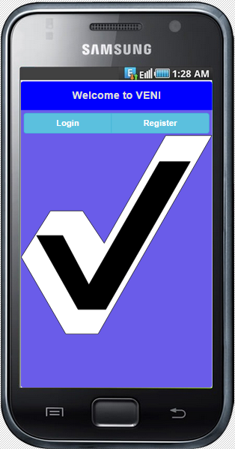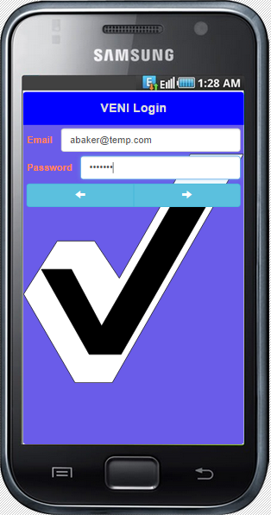

# 3. VENI First Run and Registration

If this is the user’s first time using the app, the user shall click register. This leads to a screen where the user may enter their information. When entering the facilities, the user will be taken to another screen to select a facility from a list before returning to the information screen. The user may repeat this process until the facilities list on the information screen is filled out with all of his/her facilities. Once all the information is filled out, the user will click the next arrow at the bottom of the screen. This will create the user’s account. If the account is not created, an error message will appear stating why so the user may either enter the correct information or contact the VA.

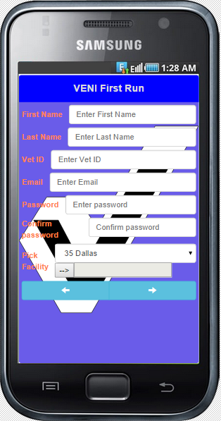

# 4. VENI Main Menu

Once user successfully logged in, it leads to VENI Main menu. The main menu includes following options.

* Fetch Appointment
* Show Appointment
* Check-in at Facility
* Direction to Facility
* Update Facility
* VENI Exit

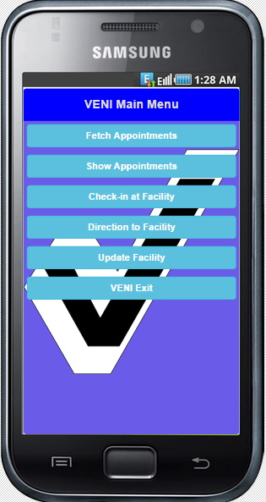

# 5. Download Appointments

To download appointments, select ‘Fetch Appointments’ from the list of options. This will take the user to a screen with a list of all of their currently scheduled appointments with the VA.

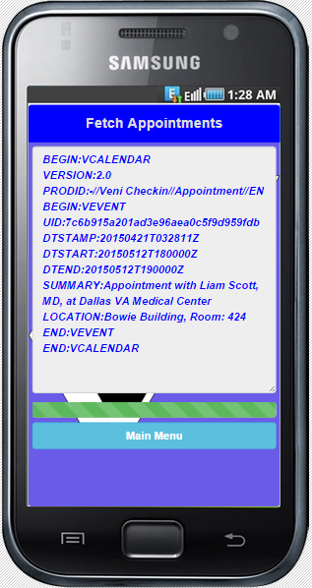

## 5.1 Add Appointments to Calendar

Once the appointment list is downloaded, this option may be chosen to send the list of appointments to the phone’s calendar. (Optional)

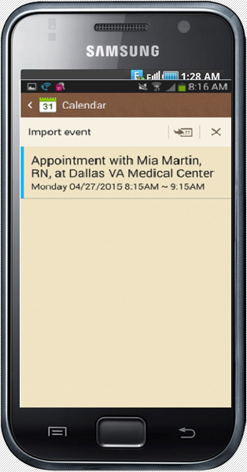

# 6. Display Appointments

To display appointments, select ‘Show Appointments’ from the list of options. This will take the user to a screen with a list of all of their currently scheduled appointments with the VA.

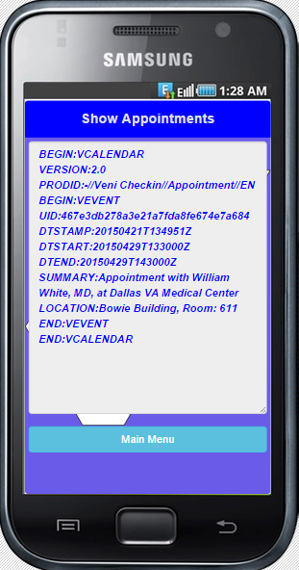

# 7. Get Directions to Facility

Once the appointment list is downloaded, the user may select an appointment and click this option to get directions to the facility for that appointment. (Optional)

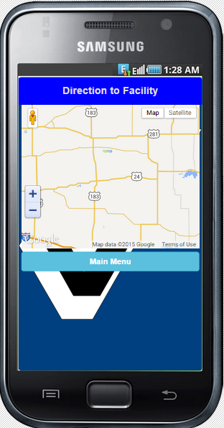

# 8. Check-In for Appointment

Once the user is at the facility for his/her appointment (within 500 meters of the location) and it is 30 minutes or less until the appointment time, the user can check in by logging into the app, selecting the appointment, and choosing the check-in option. Once the database is updated with his/her arrival, the app will display the doctor’s name and the room number of the appointment.

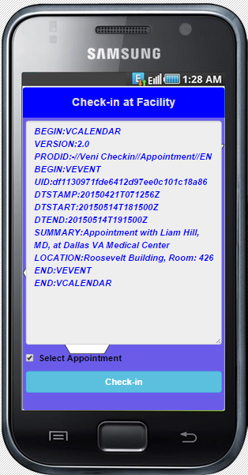

# 9. Update Facilities

Once the user is logged in, he/she can click the update facilities option. This will lead to a screen with the list of facilities to choose from. The user can select a facility, choose ‘add’ or ‘del’, and then view the resulting list of his/her facilities. This process may repeat until the list is complete.

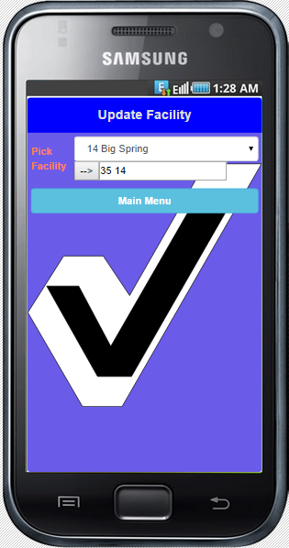

# Appendix A: Glossary

|  |  |
| --- | --- |
| **Term** | **Definition** |
| VA | Veterans Administration |
| *Veni* | Name of the system application |
| VISTA | Veterans Health Information Systems and Technology Architecture |
| PHI | Protected Health Information |
| PII | Personally identifiable information |
| HIPAA | Health Insurance Portability and Accountability Act |
| IEEE | Institute of Electrical and Electronics Engineers |
| SPMP | Software Project Management Plan |
| SRS | Software Requirements Specification |
| BWSR | Bi-Weekly Status Report |
| IEEE 1058-  1998 | the IEEE standard for Software Project Management Plans on which  this plan is based |
| VM | Virtual Machine |